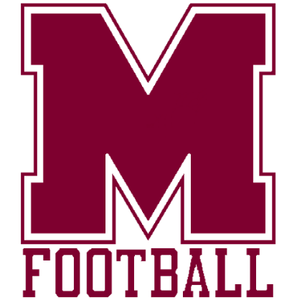

**Keith Cottrell** - Head Football Coach/Athletic Director

**Dayne Read** – Associate Head Coach/Defensive Coordinator

**Bert Givens** -Assistant Coach/Offensive Coordinator

**Ray Knight** – Assistant Coach/Offensive Line

**Tallon Campbell** – Assistant Coach/Linebacker

**Cody Ledford** – Assistant Coach/ Running backs & DL

July 2025

Prospective Montford Football Parents-

As parents ourselves, our staff recognizes that tryouts for any athletic team brings with it a heightened anxiety for both the athlete and family. It is with respect for that in mind that we want to communicate the following as tryouts near.

In the 4 years this staff has been building a program, not just an activity, we have seen interest explode as the program has seen tremendous success, culminating with the County Championship in 2024.

Tryout numbers have gone from 40 in 2022 to over 110 this year, all competing for less than 50 roster spots. For many, this is the first crack at school sports, where participation cannot be purchased and past athletic accomplishment plays no factor. We understand this is a significant shift from the current youth sports environment and experience many have had, but this is the reality as your son moves into the next stage of athletics.

The staff that has been assembled all have playing experience at the college and/or professional level, along with more than 50 years of direct coaching. Each player will be evaluated equally, fairly and fully by more than qualified eyes. Montford Football will go beyond the state minimum for tryout length in order for each player to be given ample opportunity. The collective decision of the staff will be final when made.

When the final roster is selected, we will be cognizant of the emotions on the opposite ends of the spectrum. Each player will be assigned a private tryout number and those who are selected will see their number posted to the team website at the time announced.

The most important thing to remember, ***for both parents and players***, is that the value of either is in no way impacted as a result of making or being cut from the roster. No one is more, or lesser, based upon how *any* athletic team shakes out.

As a staff, we will talk to any player who wishes to speak with us, anytime. We will not speak to parents without having spoken to the player first. This is to continue the development of the student as they mature and also because we coach our players, not their parents.

We wish everyone the best of luck as tryouts begin and thank you for your support of the bigger picture of athletics in the educational process.

**Go Mustangs!**

***The Montford Football Coaching Staff***